**Host a Website on Amazon S3**

**Project Summary**:

In this project, We will demonstrate How to use S3 bucket to host a static website.

**What is S3 Bucket:**

Amazon S3 is used to store and retrieve any amount of data at any time from anywhere on the web.

**AWS Services Used to Create in this Projects:**

* Amazon S3

**Architecture Diagram:**

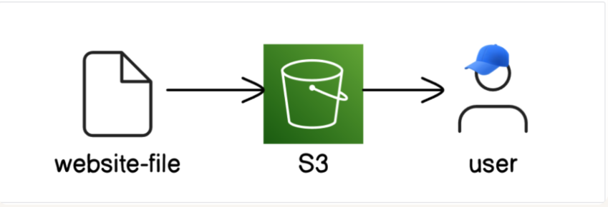

**Steps:**

**Step 1:** Login to AWS Management Console.

**Step 2:** Go to S3 Service, Next Click on General purpose buckets & Click on create Bucket.

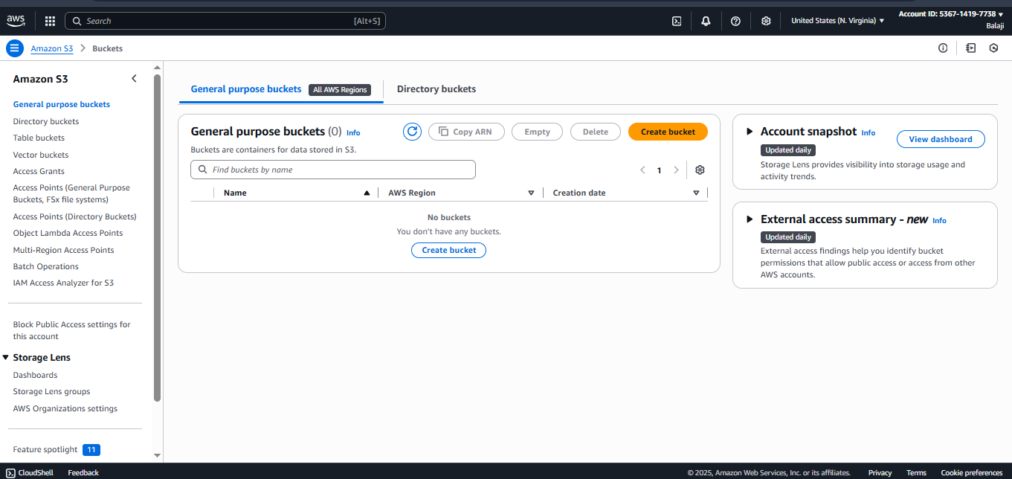

**Step 3:** Enter the s3 bucket name.

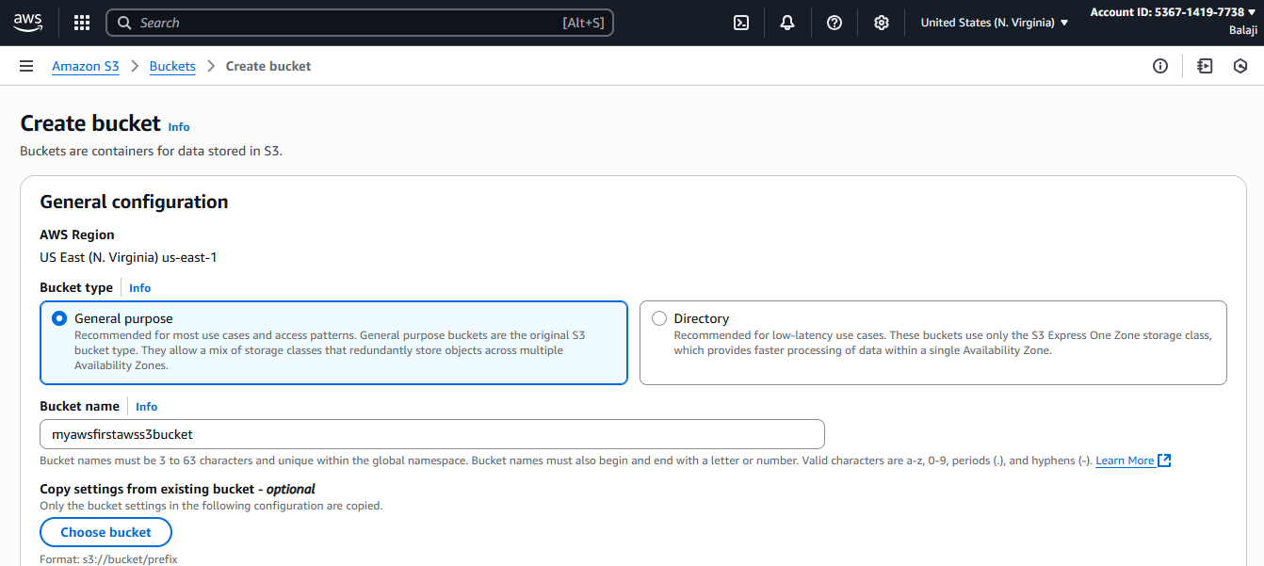

**Step 4:** Enable the object ownership option.

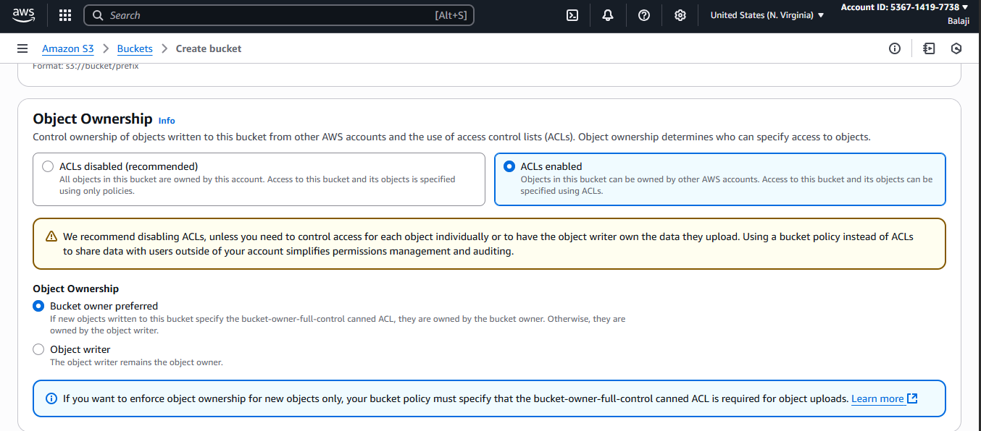

**Step 5:** Disable the Block all public access Option, because we want to allow publicly access by end-user & Enable Bucket Versioning option.

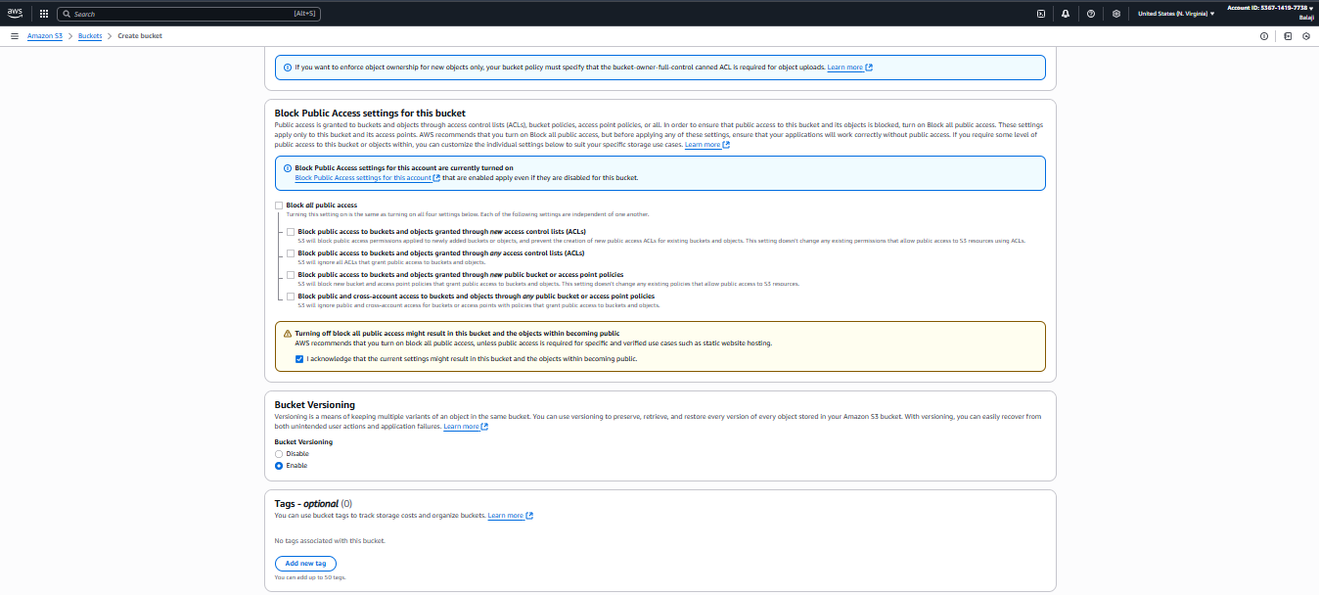

**Step 6:** Keep all the information default & Click on Create Bucket.

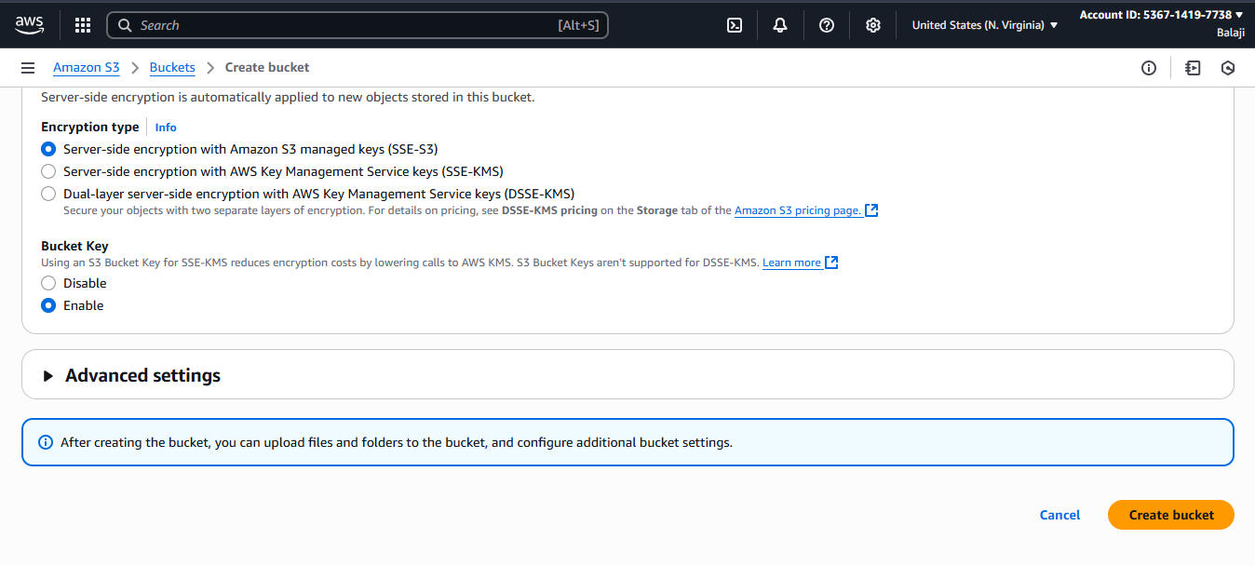

**Step 7:** Successfully bucket is created.

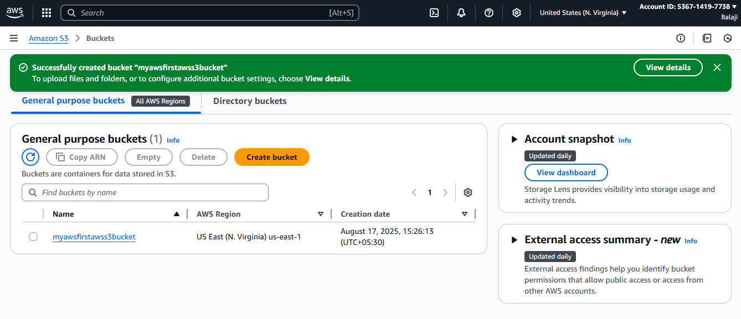

**Step 8:** Next, We have to upload the files into our S3 bucket.

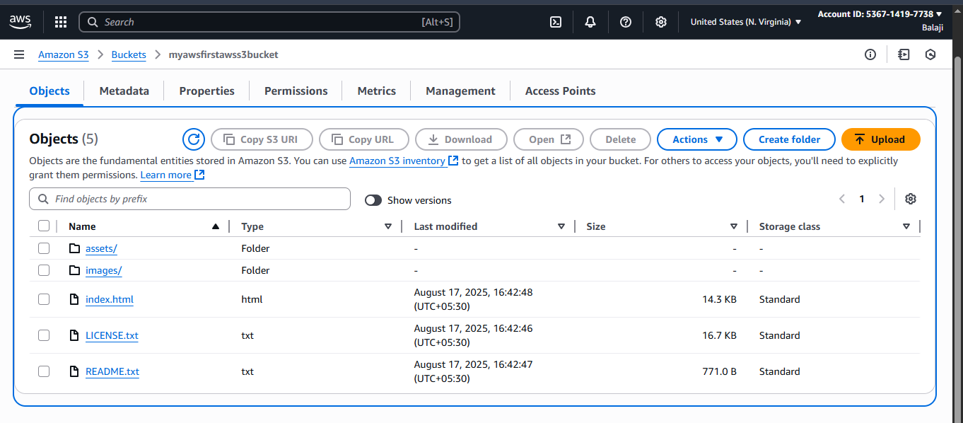

**Step 9:** Go to properties tab.



**Step 10:** Scroll fully down & click on Edit the Static Website hosting.

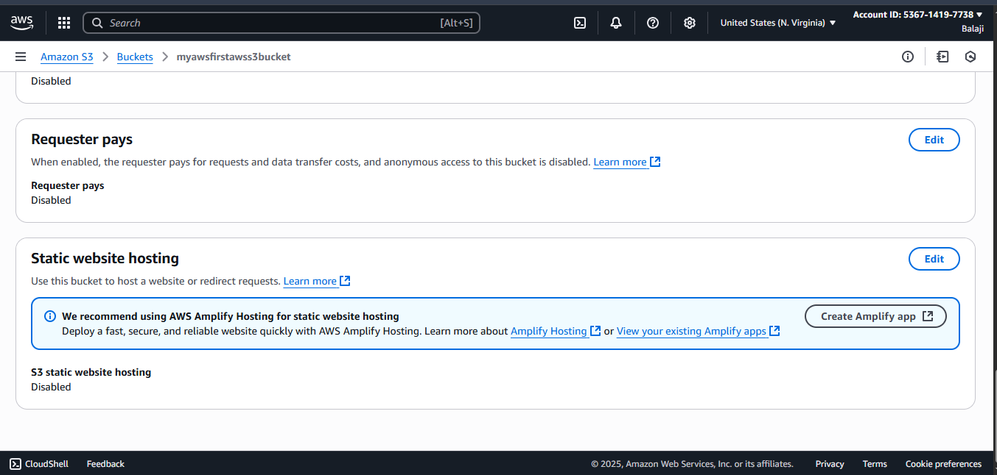

**Step 11:** Click on enable option.

**Step 12:** Select the hosting type & Enter the Index document name, Then Click on save changes.

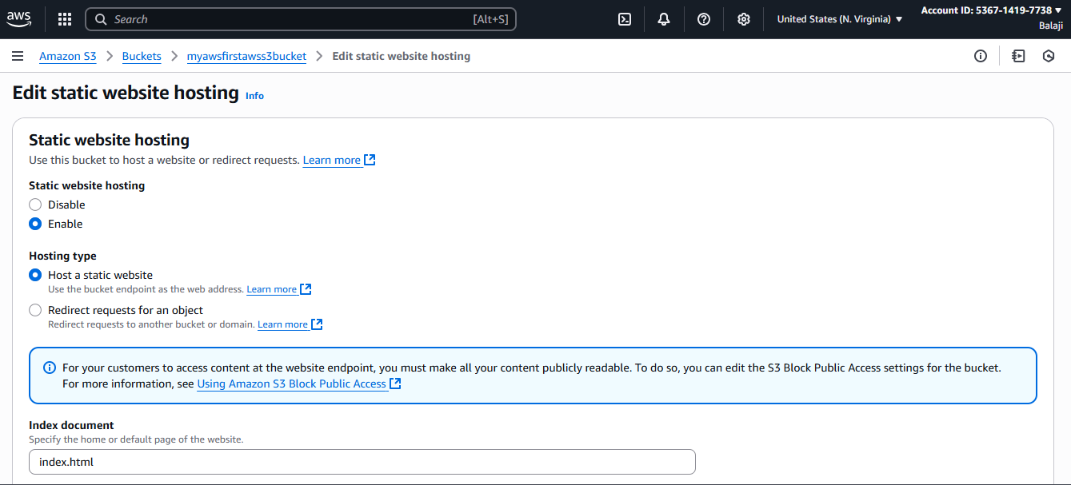

**Step 13:** Now, Successfully Enabled the static website hosting & Copy the Bucket Website Endpoint.

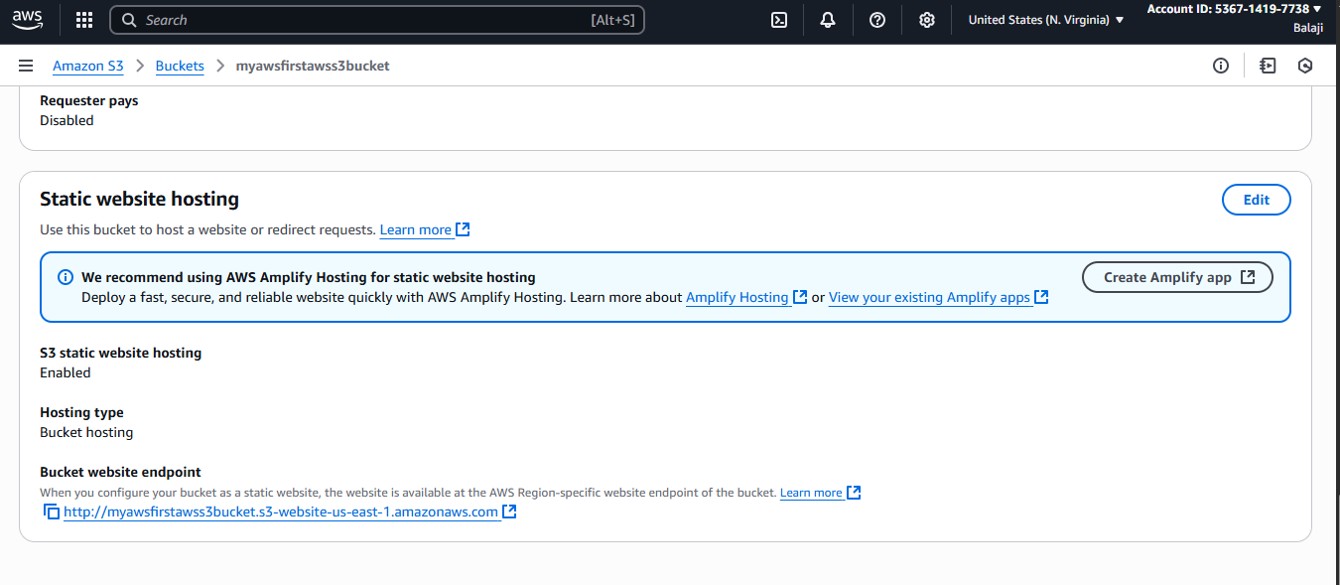

**Step 14:** Paste the URL in any of the web-browser User will get the 403 Forbidden Access Denied Error, The objects in a bucket are public access by default but Even The Website Files which user is uploaded in the s3 buckets are still in private.

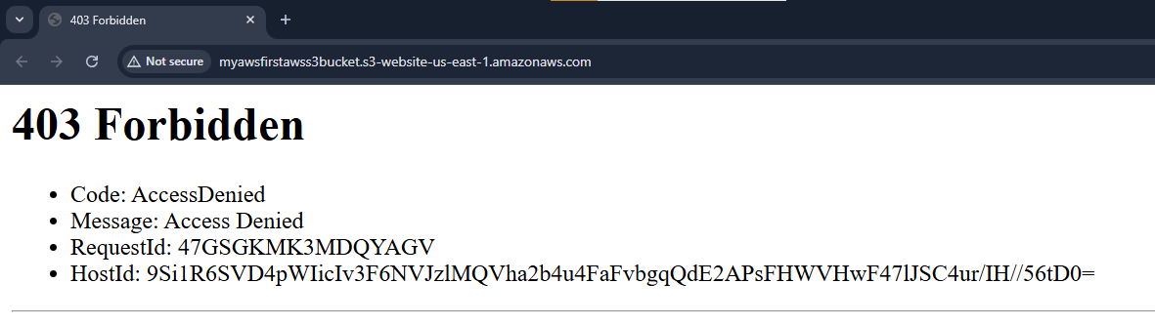

**Step 15:** User has to Select all the objects files & Go to Action > Click on Make Public using ACL.

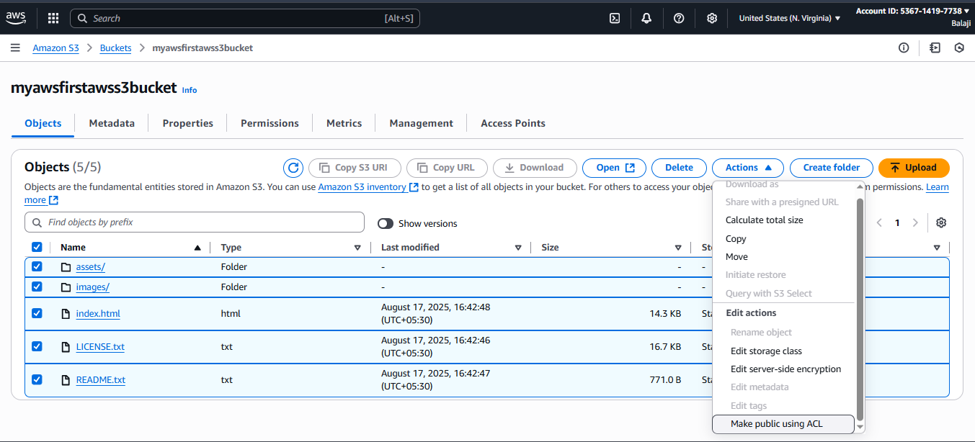

**Final Result:** Successfully We have got the static website by Using S3 Bucket.

